
Go Club Problems 8

The Winner is?
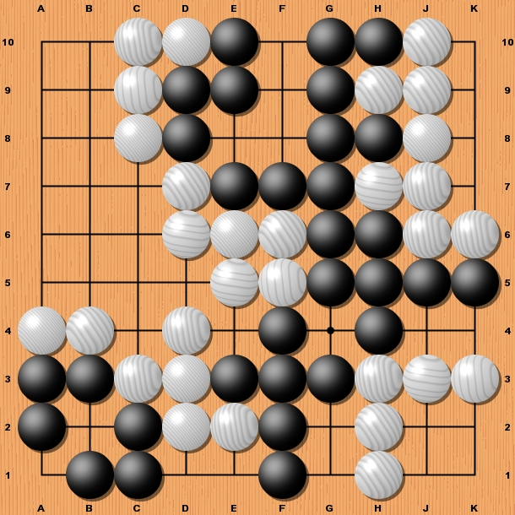

This problem only has one question. This game has now finished.

Who has won?

(You should assume that no stones have been captured during the game and komi is 0)

Solution to Problem 7
Top
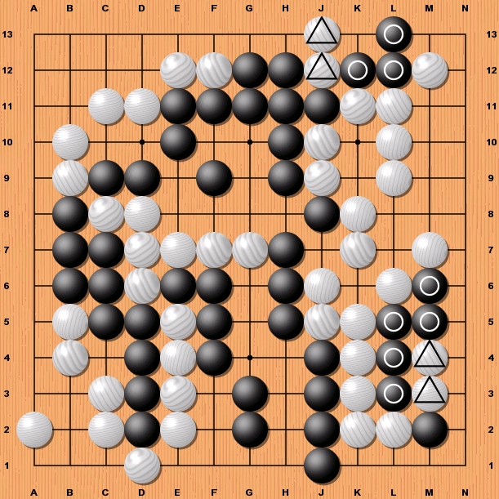
Both the white group and the black group have two liberties therefore whoever plays first will capture the other.
Note - This will result in a big swing of points for both players.
If the black group is captured white takes the corner, saves two stones and captures three.
If the white stones are captured black reduces whites area, saves three stones and captures two.

Bottom right
Again both groups have two liberties but looking closely at the situation we find differences from the top group
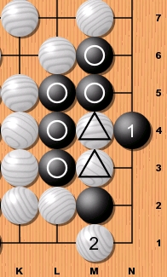
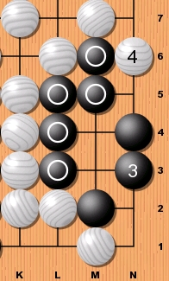

If white plays first the whole corner, including the stone on M2, is captured.

If black plays first white can use the two stones to prevent black getting two eyes. Look at the two diagrams below for the sequence of moves.

